# RESTful API for the following operations.

1. Open a new bank account.
2. Deposit funds.
3. Withdraw funds.
4. Make a payment to another account.
5. View transactions.
6. Edit the ‘Type of Account’

Solution-

Application Name – **DemoBankApi**(Please refer attached project zip file along with this file)

Technology used-

1. Spring boot 2.1.4.RELEASE
2. H2 database(In memory database)( <http://localhost:8080/h2-console>)
3. Maven 3.6.0
4. SLF4J logger

**1.Open a new bank account.**

End Point- <http://localhost:8080/account/createAccount>

Method type-**POST**

Sample Input json-

{

*"accountHolderFirstName": "Santosh",*

*"accountHolderLastName": "Darvandar",*

*"accountHolderDateOfBirth": "1988-03-16",*

*"acccounType": "Saving"*

*}*

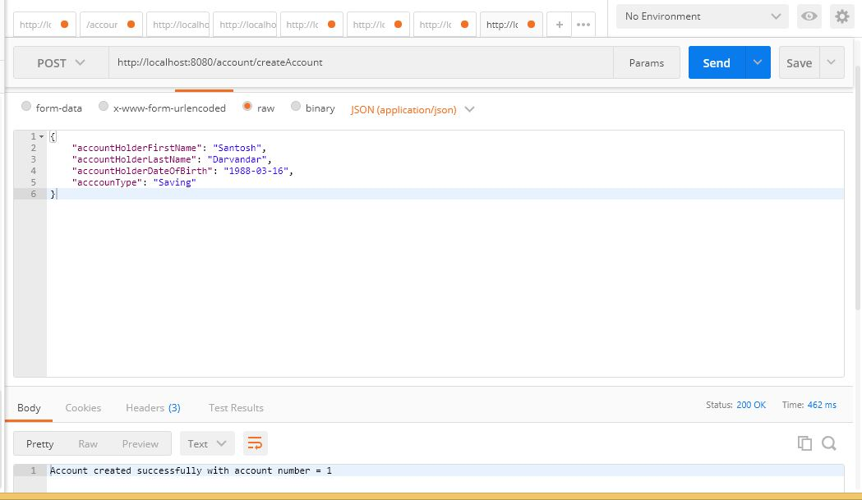

**2.Deposit funds.**

End Point- [http://localhost:8080/account/deposit/{accountNumber}](http://localhost:8080/account/deposit/%7baccountNumber%7d)

Method type-**PUT**

http://localhost:8080/account/deposit/1

Sample Input json-

*{*

*"amount": "200"*

*}*

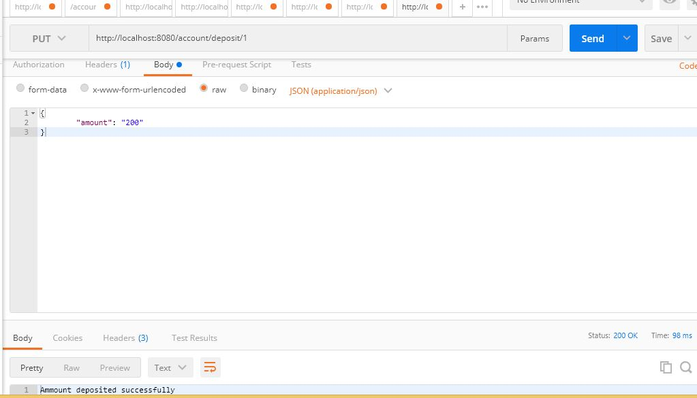

**3.Withdraw funds.**

End Point- [http://localhost:8080/account/withdraw/{accountNumber}](http://localhost:8080/account/withdraw/%7baccountNumber%7d)

Method type-**PUT**

http://localhost:8080/account/withdraw/1

Sample Input json-

*{*

*"amount": "50"*

*}*

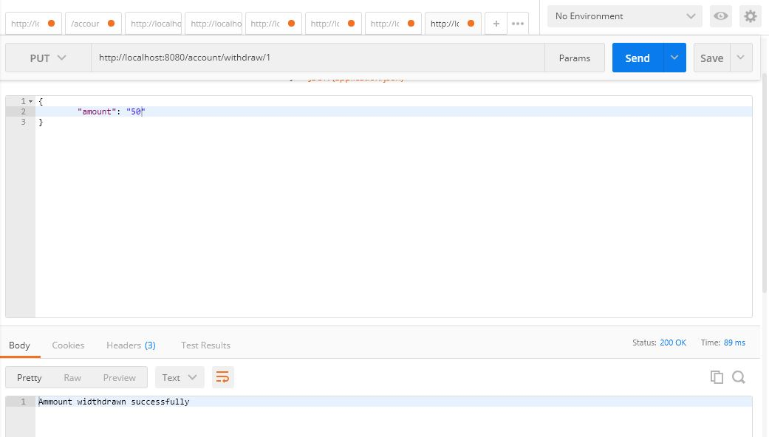

**4. Make a payment to another account.**

End Point- <http://localhost:8080//transaction/paymentTransfer>

Method type-**PUT**

Sample Input json-

*{*

*"fromAccountId": "1",*

*"toAccountId": "2",*

*"amount": "20"*

*}*

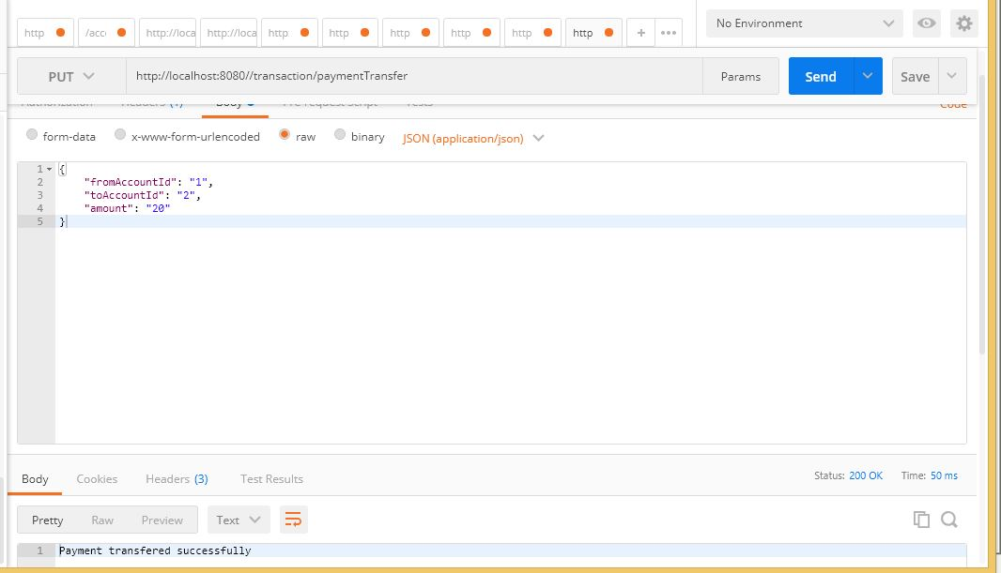

## Before transfer in DB

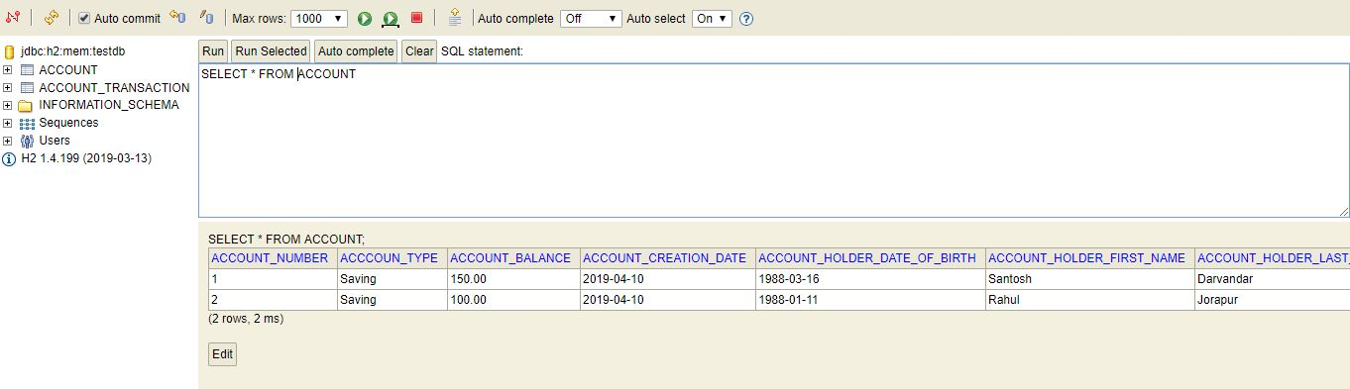

After Trasfer in DB

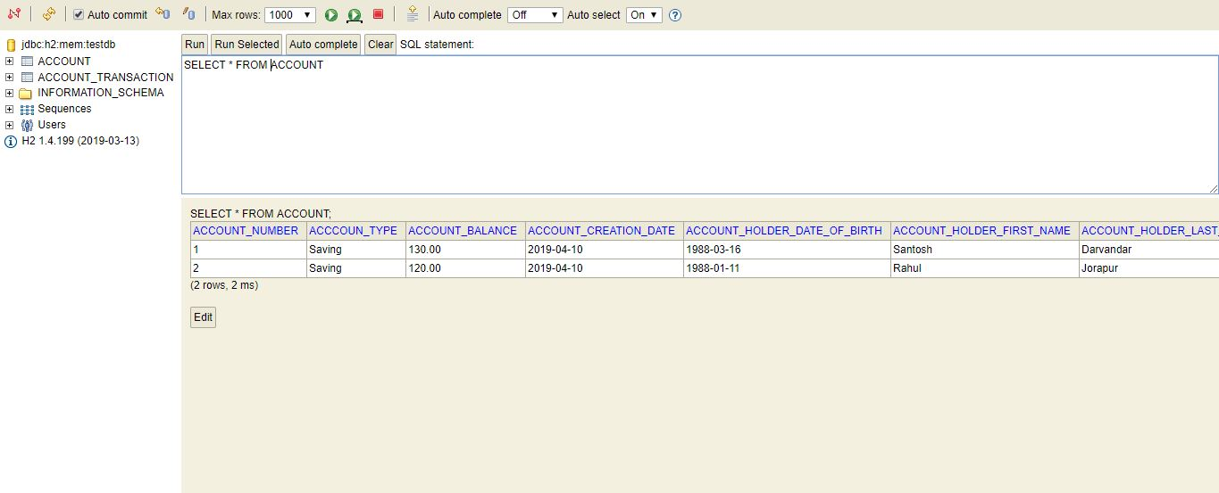

**5. View transactions**

End Point- http://localhost:8080/transaction/viewAllTransactions

Method type-**GET**

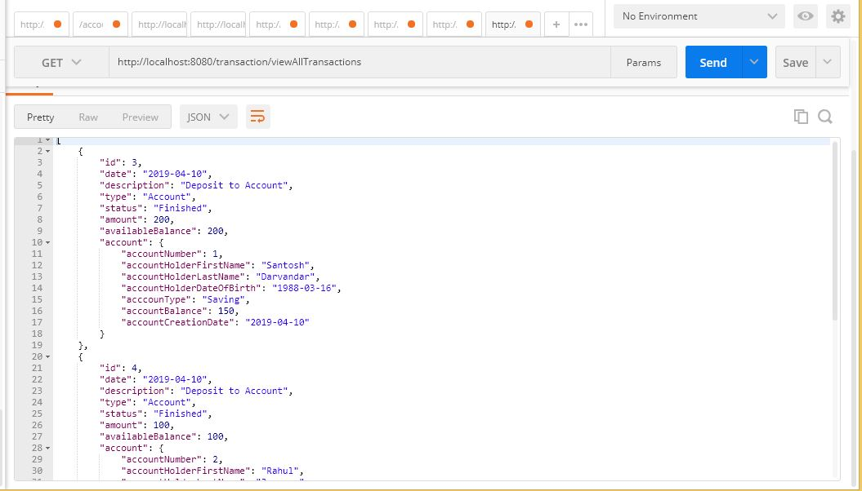

**6. Edit the ’Type of Account’.**

End Point - [http://localhost:8080/account/changeAccountType/{accountNumber}](http://localhost:8080/account/changeAccountType/%7baccountNumber%7d)

Method type-**PUT**

http://localhost:8080/account/changeAccountType/1

Sample Input json-

{

"acccounType": "Current"

}

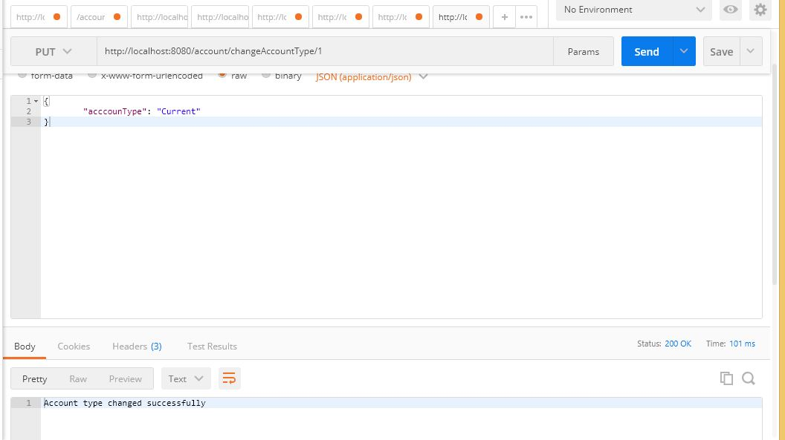

**H2 Database console**

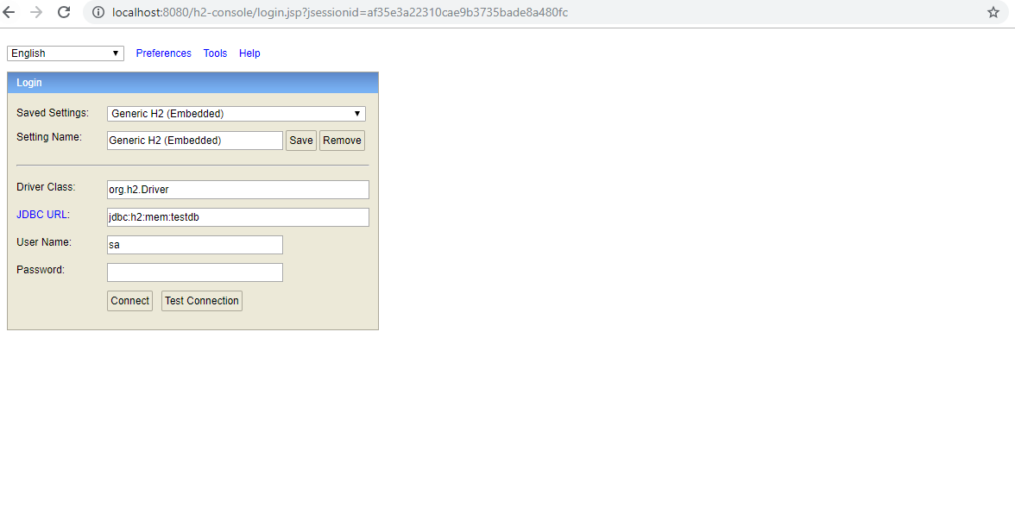

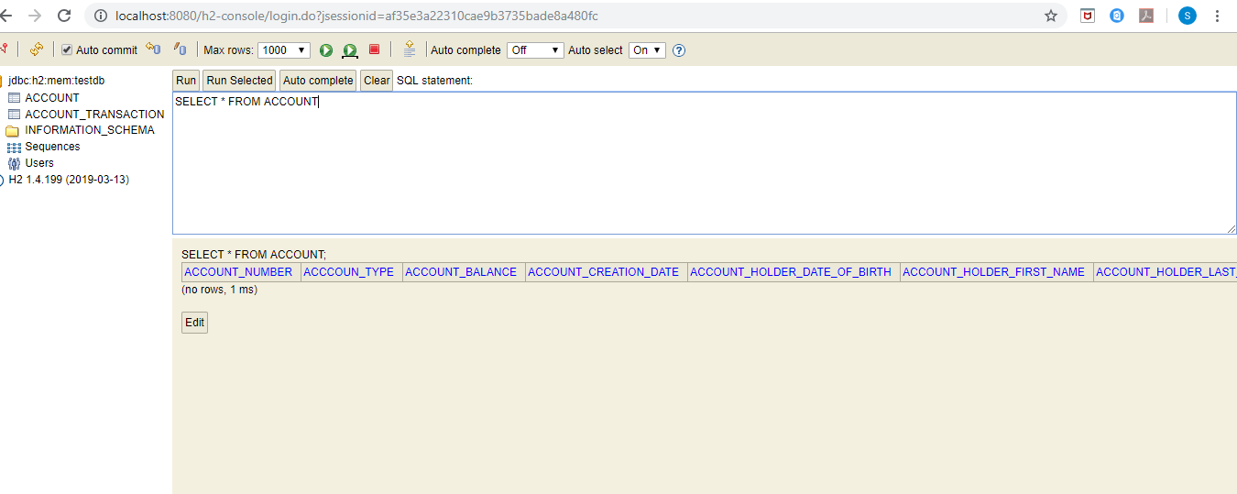

**Exception Handling:**

Business Exception Name – InsufficientAccountBalanceException.java

Description - Used to handle insufficient balance.

